SOC Design

Lab4-1 Execute Code in User Memory

112061611陳伯丞, 112061524葉又菘, 110063553 張傑閔

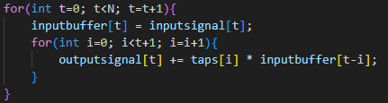

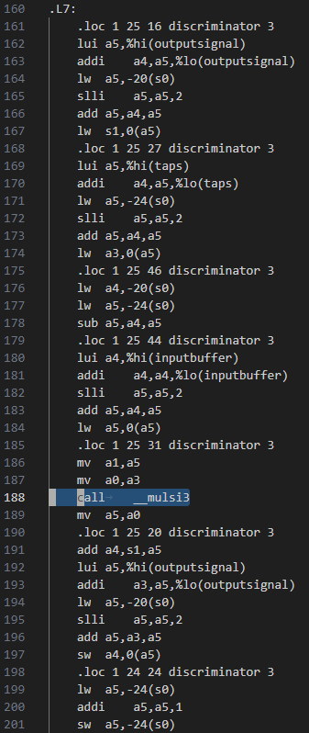

* 1. According to the screenshot, user project is allocated in . The space requirement of firmware code is 2448 Bytes.

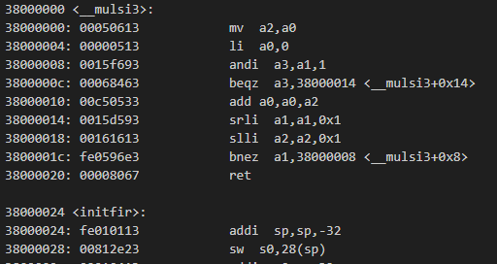

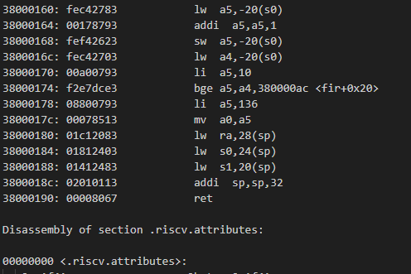

1. Waveform from XSIM

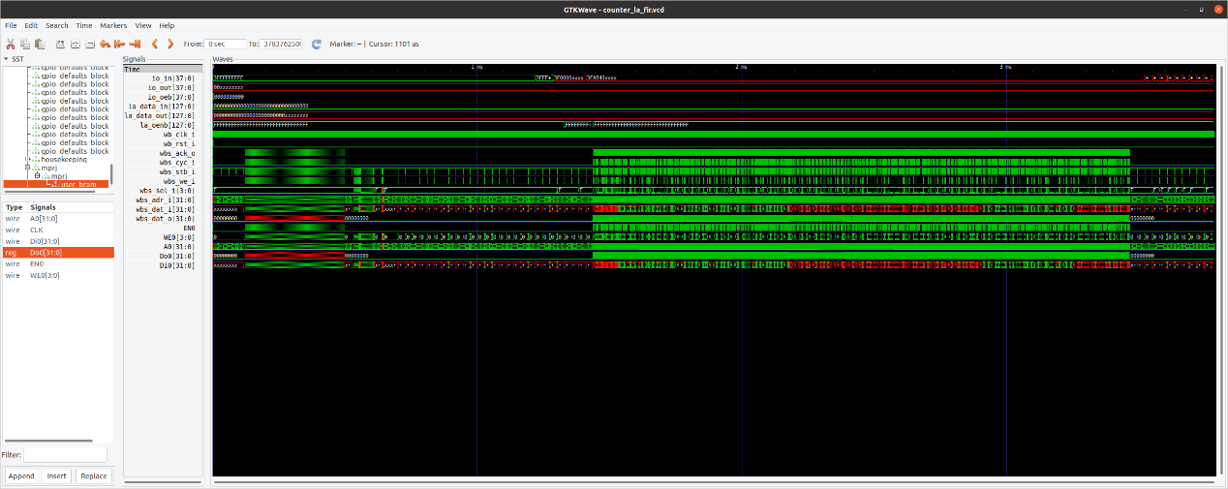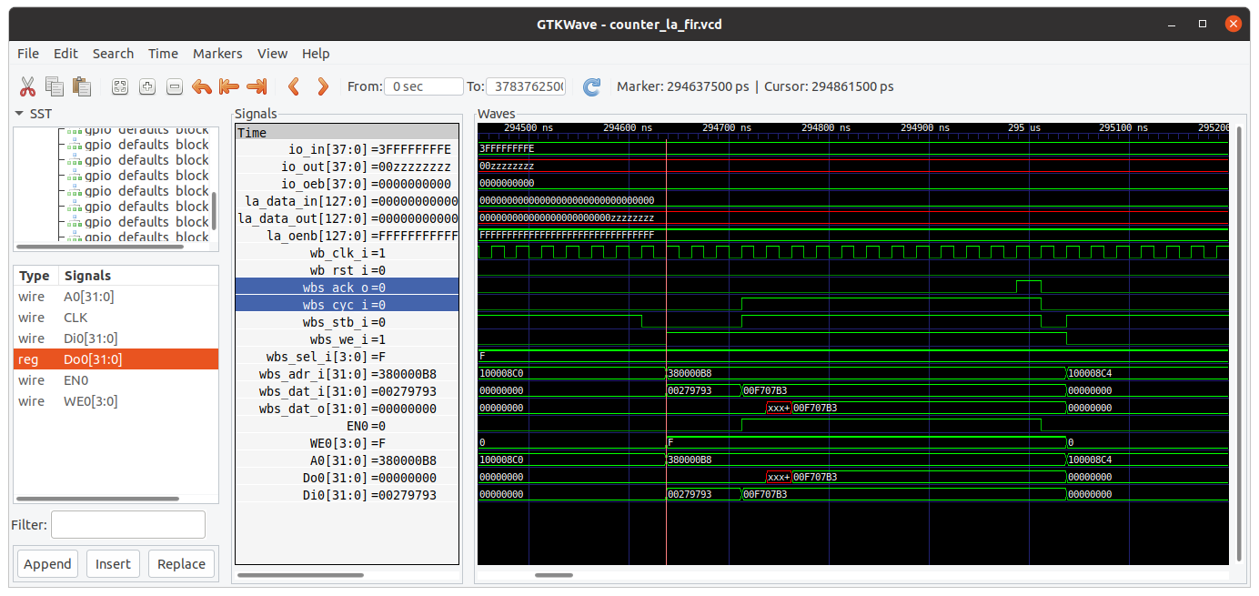

Delay between and is 10 clock cycle.

BRAM write:

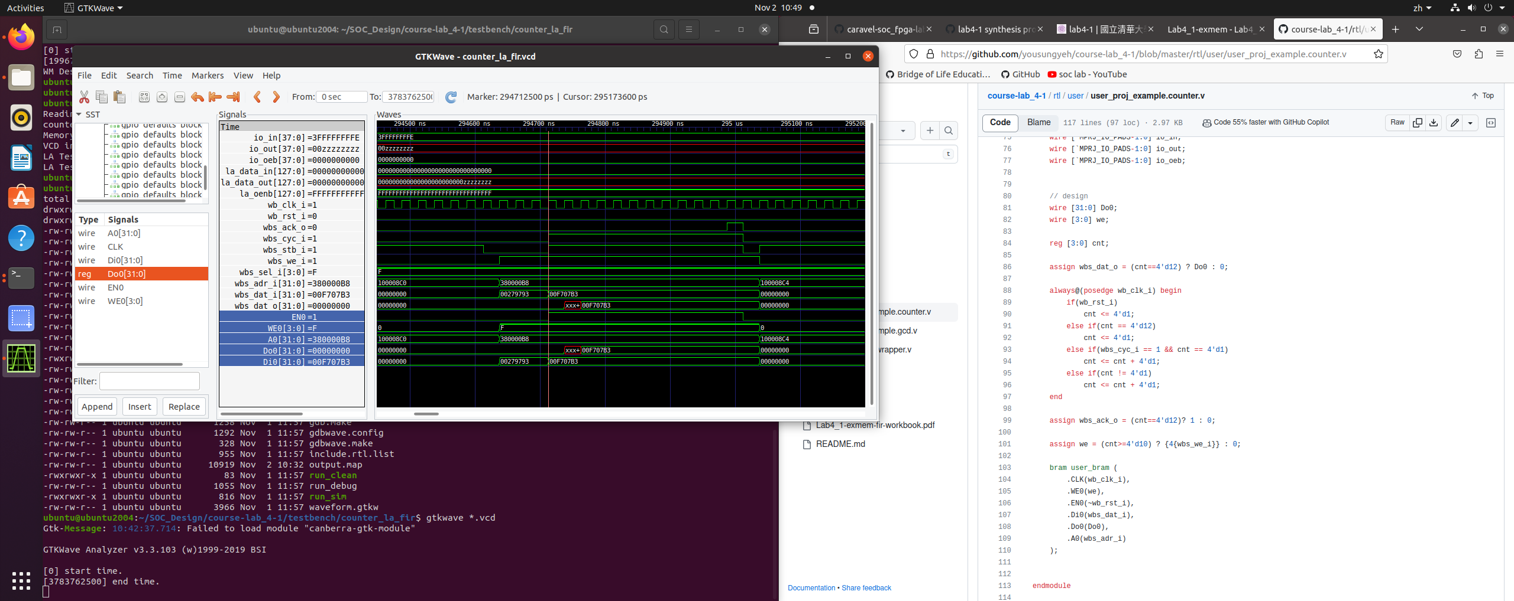

BRAM read:

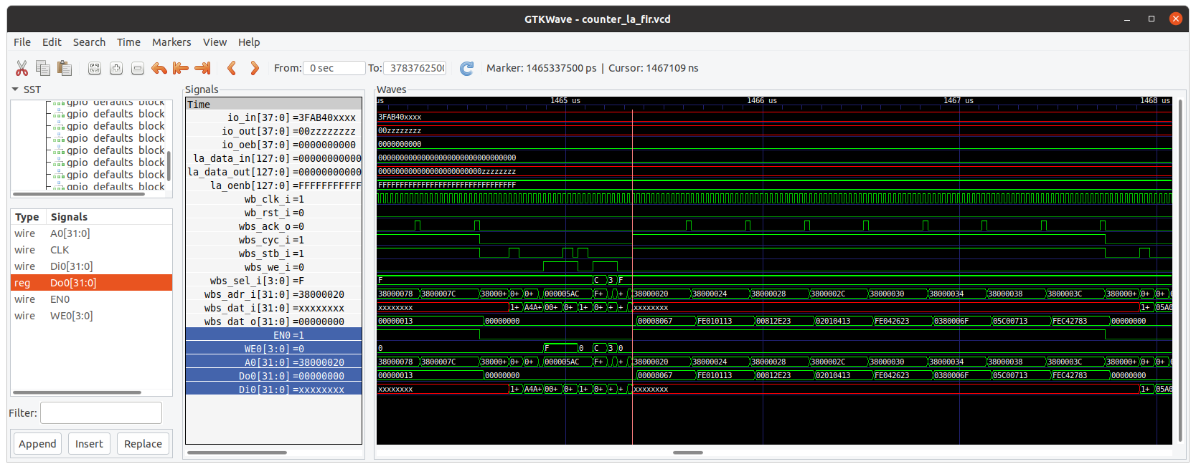

1. Synthesis report

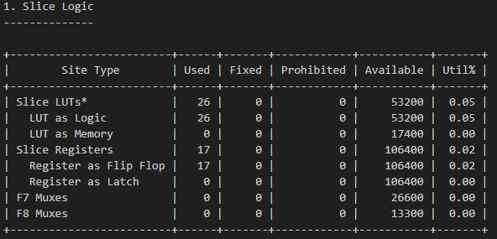

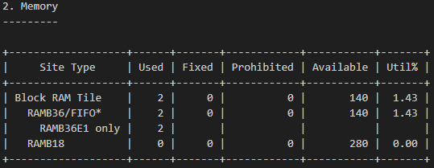

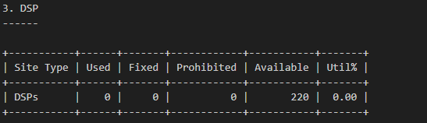

1. Git Link:

<https://github.com/ken01235/SOC_Design/tree/master/course-lab_4-1>